*Subject literacy development (TR/5A, GPS, student handout)*

**Read the text about GPS technology.**

**What is GPS ?**

The Global Positioning System (GPS) is a satellite navigation system, providing users with positioning and timing services. The U.S. military developed and implemented this system as a military navigation system, but soon opened it up to everybody else.

The system consists of a network of satellites transmitting radio signals to Earth. For the past several years, the US Air Force has been flying 31 operational GPS satellites. A global network of ground facilities are used to track the GPS satellites and monitor their transmissions.

To use GPS technology, a user needs a GPS receiver which receives the signals from the GPS satellites and uses the transmitted information to calculate the user’s position (latitude, longitude, altitude) and time.

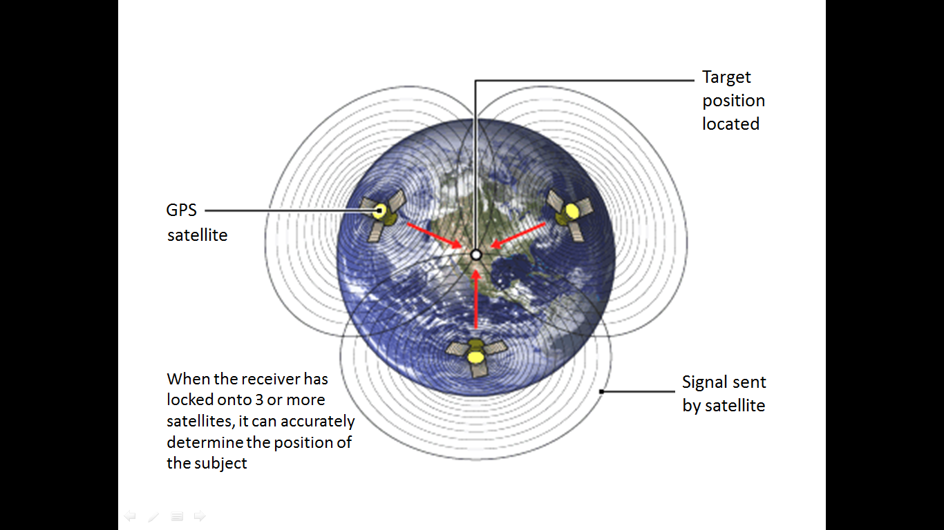

*Figure 1: How GPS Works (Source:* [*BBC*](http://news.bbc.co.uk/2/hi/africa/7218078.stm)*)*

Like the Internet, GPS is an essential element in many aspects of modern life. GPS technology is now in everything from cell phones and watches to bulldozers, shipping containers, and cash machines.

GPS improves productivity in industries such as agriculture, construction and package delivery. Some wireless services cannot operate without it. It also saves lives by preventing transportation accidents, assisting search and rescue efforts, and speeding the delivery of emergency services. GPS is important in many scientific areas including weather forecasting and earthquake monitoring.

GPS technology has also been used during the installation of the solar power plant on the roof of the Secondary School of Technical Professions Šiška. One of the units of the power plant uses a solar tracking system. While the tracker uses astronomical data from a computer in order to track the sun, its exact location had to be determined for the tracking process to be precise. This was achieved using a GPS receiver at the time the unit was installed. Some of the latest solar trackers have built-in GPS technology, so it is possible to automatically configure them for any geographic location and to provide precise time synchronization.

***Sources:***[*(1)*](http://www.gps.gov/systems/gps/) *www.gps.gov (March 2013),* [*(2)*](http://www.elektro-ljubljana.si/en/1/Renewable-Energy-Sources/Solar-Power-Plants/Solar-Power-Plant-at-Litostroj-Distribution-Transf.aspx) *www.elektro-ljubljana.si (March 2013)*

**Task 1 Translate the terms into English.**

|  |  |
| --- | --- |
| **Slovene** | **English** |
| GPS sprejemnik |  |
| geografska širina |  |
| sledilnik sonca |  |
| radijski signali |  |
| geografska dolžina |  |
| sistemi satelitske navigacije/satelitski navigacijski sistemi |  |
| astronomski podatki |  |
| nadmorska višina |  |

**Task 2 Fill in the gaps using the translated terms from Task 1.**

The Global Positioning System (GPS) and Global Navigation Satellite System (GLONASS) are two examples of **(1)** ___________________________________.

GPS satellites transmit **(2)** ________________________________ which are captured by

**(3)** ____________________________.

GPS technology provides users with information such as:

**(4)** ______________________________ (their distance, in degrees, from the equator);

**(5)** ______________________________ (their distance, in degrees, from the Greenwich meridian);

and **(6)** ______________________________ (their height above sea level).

**(7)** _______________________________________ from a computer is used to control the

**(8)** ________________________ on the roof of our school.

|  |  |
| --- | --- |
|  | *Figure 2: GPS Pet Locator*  *(Source:* [*PocketFinder*](http://www.pocketfinder.com/wp-content/uploads/2012/11/Pets-Compilation-web.jpg)*)* |

**Task 3 Draw a Frayer model for the term “satellite navigation system”.**

**Task 4 What, according to you, are the drawbacks of GPS technology?**

|  |
| --- |
| ***In my opinion…***  *______________________________________________________________________________________*  *______________________________________________________________________________________*  *______________________________________________________________________________________*  *______________________________________________________________________________________*  *______________________________________________________________________________________*  *______________________________________________________________________________________*  *______________________________________________________________________________________*  *______________________________________________________________________________________* |

*Subject literacy development (TR/5A, GPS, teacher version)*

**Read the text about GPS technology.**

**What is GPS ?**

The Global Positioning System (GPS) is a satellite navigation system, providing users with positioning and timing services. The U.S. military developed and implemented this system as a military navigation system, but soon opened it up to everybody else.

The system consists of a network of satellites transmitting radio signals to Earth. For the past several years, the US Air Force has been flying 31 operational GPS satellites. A global network of ground facilities are used to track the GPS satellites and monitor their transmissions.

To use GPS technology, a user needs a GPS receiver which receives the signals from the GPS satellites and uses the transmitted information to calculate the user’s position (latitude, longitude, altitude) and time.



*Figure 1: How GPS Works (Source:* [*BBC*](http://news.bbc.co.uk/2/hi/africa/7218078.stm)*)*

Like the Internet, GPS is an essential element in many aspects of modern life. GPS technology is now in everything from cell phones and watches to bulldozers, shipping containers, and cash machines.

GPS improves productivity in industries such as agriculture, construction and package delivery. Some wireless services cannot operate without it. It also saves lives by preventing transportation accidents, assisting search and rescue efforts, and speeding the delivery of emergency services. GPS is important in many scientific areas including weather forecasting and earthquake monitoring.

GPS technology has also been used during the installation of the solar power plant on the roof of the Secondary School of Technical Professions Šiška. One of the units of the power plant uses a solar tracking system. While the tracker uses astronomical data from a computer in order to track the sun, its exact location had to be determined for the tracking process to be precise. This was achieved using a GPS receiver at the time the unit was installed. Some of the latest solar trackers have built-in GPS technology, so it is possible to automatically configure them for any geographic location and to provide precise time synchronization.

***Sources:***[*(1)*](http://www.gps.gov/systems/gps/) *www.gps.gov (March 2013),* [*(2)*](http://www.elektro-ljubljana.si/en/1/Renewable-Energy-Sources/Solar-Power-Plants/Solar-Power-Plant-at-Litostroj-Distribution-Transf.aspx) *www.elektro-ljubljana.si (March 2013)*

**Task 1 Translate the terms into English.**

|  |  |
| --- | --- |
| **Slovene** | **English** |
| GPS sprejemnik | ***GPS receiver*** |
| geografska širina | ***latitude*** |
| sledilnik sonca | ***solar tracker*** |
| radijski signali | ***radio signals*** |
| geografska dolžina | ***longitude*** |
| sistemi satelitske navigacije/satelitski navigacijski sistemi | ***satellite navigation systems*** |
| astronomski podatki | ***astronomical data*** |
| nadmorska višina | ***altitude*** |

**Task 2 Fill in the gaps using the translated terms from Task 1.**

The Global Positioning System (GPS) and Global Navigation Satellite System (GLONASS) are two examples of **(1) satellite navigation systems**.

GPS satellites transmit **(2) radio signals** which are captured by **(3) GPS receivers**.

GPS technology provides users with information such as:

**(4) latitude** (their distance, in degrees, from the equator);

**(5) longitude** (their distance, in degrees, from the Greenwich meridian);

and **(6) altitude** (their height above sea level).

**(7) Astronomical data** from a computer is used to control the **(8) solar tracker** on the roof of our school.

|  |  |
| --- | --- |
|  | *Figure 2: GPS Pet Locator*  *(Source:* [*PocketFinder*](http://www.pocketfinder.com/wp-content/uploads/2012/11/Pets-Compilation-web.jpg)*)* |

**Task 3 Draw a Frayer model for the term “satellite navigation system”.**

**Task 4 What, according to you, are the drawbacks of GPS technology?**

|  |
| --- |
| ***In my opinion…***   * We will be too dependent on GPS technology, for example, due to car navigation systems, the younger generation will not develop map reading skills. * Privacy could be a problem (your movement could easily be tracked by a group of people, if they have the appropriate hardware). * It is not always accurate. You need a powerful GPS receiver for good accuracy. * Some additional services can be expensive (better frequency ranges). * Some services need constant updates in order to work properly (databases and maps). |
|  |